**Ubuntu 22.04 + Apache2**

**Prerequisites:**

* **Ubuntu 22.04**
* **Apchache2 – 2.4.52 ($apache2 -v)**
* **Postgresql v13 (see the separate postgresql note)**
* **Mod_wsgi (v4.7.1) installed from source**

1. Log in to Ubuntu 22.04 as marvin (has sudo privilege – checking by (a) vi /etc/group; (b) getent group sudo; (c) cat /etc/group | grep sudo* )
2. Check **apache2** version, install it if not installed already

* $apache2 -v
* Sudo apt update
* Sudo apt install apache2

1. Ensure firewall is set up correctly

* Sudo ufw app list
* 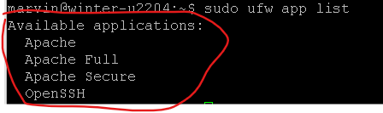
  + Apache: This profile opens only port 80 (normal, unencrypted web traffic)
  + Apache Full: This profile opens both port 80 (normal, unencrypted web traffic) and port 443 (TLS/SSL encrypted traffic)
  + Apache Secure: This profile opens only port 443 (TLS/SSL encrypted traffic)
* Sudo ufw allow ‘Apache’

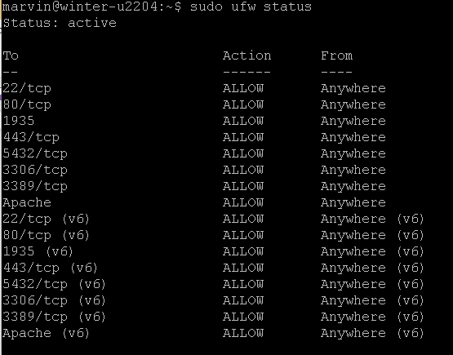

1. mkdir /var/www/ww-site
2. cd /var/www/ww-site
3. /var/www/ww-site$ Create a venv: python3 -m venv venv
4. /var/www/ww-site$ Source venv/bin/activate
5. /var/www/ww-site$ sudo mkdir winter-winn
6. /var/www/ww-site$ sudo chmod 755 winter-winn -R
7. /var/www/ww-site$ sudo chown :www-data winter-winn
8. /var/www/ww-site$ cd winter-winn
9. /var/www/ww-site/winter-winn$ git init;
10. /var/www/ww-site/winter-winn$ git remote add origin <https://github.com/marvinxu99/py_django_pg_winn.git> (py_django_pg_winn is the staging repo)
11. /var/www/ww-site/winter-winn$ git fetch -all
12. /var/www/ww-site/winter-winn$ git reset --hard origin/master
13. Postgresql created a database named “winn_la_1”
    1. sudo su – postgres
    2. psql
    3. #\l - to display all databases
    4. CREATE DATABASE winn_la_1 OWNER winter
14. /var/www/ww-site/winter-winn$ pip3 install -r requirements.txt
    1. **sudo apt-get install libpq5=14.5-0ubuntu0.22.04.1**
    2. **sudo apt-get install libpq-dev=14.5-0ubuntu0.22.04.1**
    3. **pip3 install psycopg2**
15. Define environment variables – defined in two places:

**Sudo vi /etc/environment - globally**

DEBUG=TRUE

DOMAIN=PROD

PROD_DEPLOY=False

MY_GMAIL=marvinxu99@gmail.com

MY_GMAIL_PASSWORD=xxxxx

SECRET_KEY="f$lb=m=vqb-!9w&s#+ocv5xxxxxxxxxxxx"

ALLOWED_HOSTS=’localhost,127.0.0.1,192.168.0.48,24.80.60.154,www.winnpysoft.com’

STRIPE_SECRET_KEY=sk_test_We3NuLp9TD0rpjhctRPRaJ0z00XBTGD6mN

OXFORD_APP_ID=7731991b

OXFORD_APP_KEY=c9ef14ef5a2829e80b51xxxxxxxxx

DB_NAME=winn_la_1

DB_USER=winter

DB_USER_PASSWD=xxxxxx

DB_HOST=localhost

DB_PORT=5432

sudo vi /ect/apache2/envvars, add the following to the bottom.

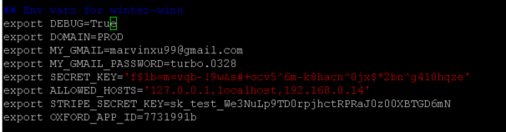

(See C:\Users\marvi\OneDrive\dev\.env_winn settings)

1. /var/www/ww-site/winter-winn$ Python3 manage.py collectstatic
2. **Install GNU gettext tools 0.15 or newer**: sudo apt install gettext
3. /var/www/ww-site/winter-winn$ Make compilemessages as needed (if support multiple lanaguages);
   1. Python3 manage.py compilemessages -l zh_Hans
4. > python manage.py migrate
5. > python manage.py createsuperuser
6. > python manage.py runserver - ensure there are no errors, then CTRL-C to exit
7. Install mod_wsgi (see separate install guide) if not done already.
8. cd /etc/apache2/sites-available
9. /etc/apache2/sites-available$ sudo cp 000-default.conf winter-winn.conf
10. /etc/apache2/sites-available$ sudo chown $USER:$USER winter-winn.conf
11. /etc/apache2/sites-available$ vi winter-winn.conf
12. Ensure the following settings are correct: (in the screenshot, the venv is /var/www/ww-site/venv. Website path is at /var/www/ww-site/winter-winn.
13. 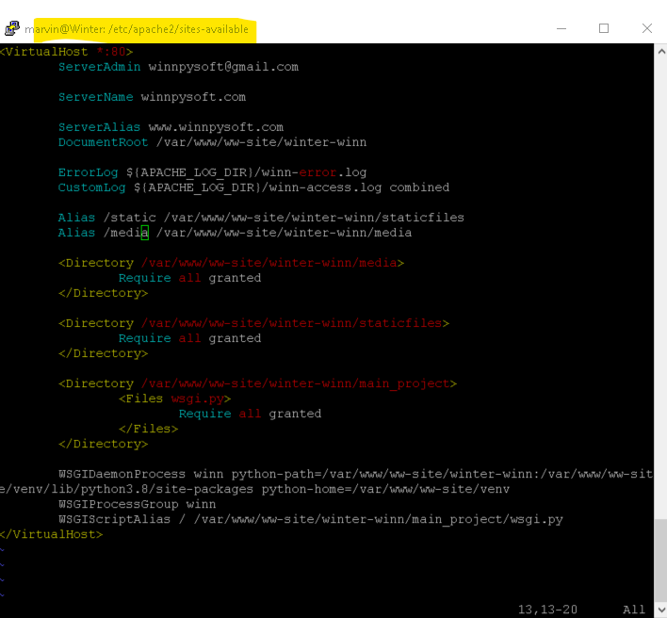
14. Sudo a2ensite winter-winn.conf (if needed, sudo a2dissite 000-default.conf or mysite.conf)
15. cd /etc/apache2/sites-enabled. The winter-winn.conf should be listed here
16. Sudo systemctl reload apache2 ( or sudo service apache2 stop; sudo service apache2 start)
17. Open winnpysoft.com, and ensure media files can be uploaded for iTrac app.pos

Checking the logs:

$ tail -f /var/log/apache2/winn-access.log

$ tail -f /var/log/apache2/winn-error.log

Ensure the following is correct in the /etc/apache2/apache2.conf (for mod_wsgi configure, installed from source)



**Ensure to allow remote access to Postgres Database**

Ensure sudo ufw allow 5432/tcp

Ensure in the /etc/postgresql/13/main/pg_hba.conf

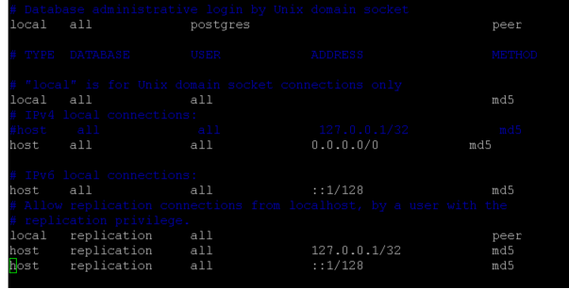

Ensure in the /etc/postgresql/13/main/postgresql.conf

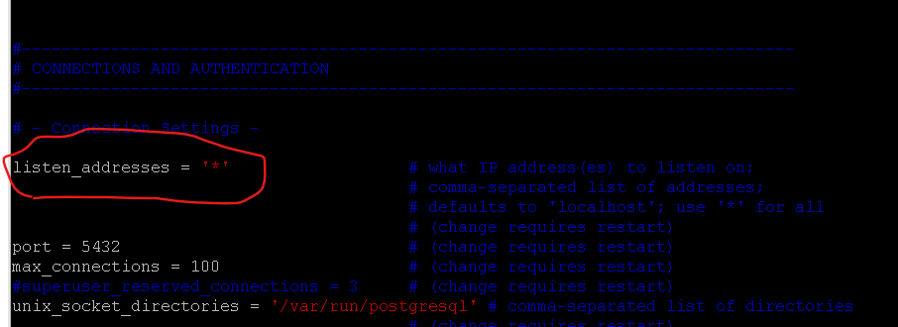

Sudo systemctl restart postgresql

**Environment variables**:

DB_NAME,

DB_USER,

DB_HOST etc are set in the two places:

(1) /etc/environment - globally

(2) also at /etc/apache2/envvars

- the ones defined here will overwrite thosed defined in /etc/environment